Analysis of 2-D Game by Using Gesture Recognition and NLP

**Authors:**

1. **Mrs Manisha V Khadse** – Co author

**Institution**: Dr DY Patil Institute of Engineering, Management and Research, Akurdi, Pune

**Department**: Computer Science

**City**: Pune

**State**: Maharashtra

**Country**: India

**Email ID**: [manishakdyp5@gmail.com](mailto:manishakdyp5@gmail.com)

1. **Ms Pratiksha Darade**

Institution: Dr DY Patil Institute of Engineering, Management and Research, Akurdi, Pune

Department: Computer Science

City: Pune

State: Maharashtra

Country: India

Email ID: [pratikshadarade12@gmail.com](mailto:pratikshadarade12@gmail.com)

1. **Ms Shejal Aute**

**Institution**: Dr DY Patil Institute of Engineering, Management and Research, Akurdi, Pune

**Department**: Computer Science

**City**: Pune

**State**: Maharashtra

**Country**: India

**Email ID**: [shejal.aute101@gmail.com](mailto:shejal.aute101@gmail.com)

1. **Ms Suhani Patil**

**Institution**: Dr DY Patil Institute of Engineering, Management and Research, Akurdi, Pune

**Department**: Computer Science

**City**: Pune

**State**: Maharashtra

**Country**: India

**Email ID**: [suhanipatil2003@gmail.com](mailto:suhanipatil2003@gmail.com)

1. **Ms Rutuja Madane**

**Institution**: Dr DY Patil Institute of Engineering, Management and Research, Akurdi, Pune

**Department**: Computer Science

**City**: Pune

**State**: Maharashtra

**Country**: India

**Email ID**: [rutujamadane17@gmail.com](mailto:rutujamadane17@gmail.com)

**Abstract:** In a realm where communication transcends traditional spoken language and written text, hand gestures emerge as the natural, intuitive, and contemporary mode of interaction. This paradigm shift in non-verbal communication not only promises seamless interaction with computers but also offers a vital bridge for individuals who rely on sign language. This paper delves into an innovative system designed for hand gesture recognition, focusing on the detection of shape-based features. At its essence, the system relies on a solitary camera as its primary sensory tool, capturing and interpreting user gestures. Through sophisticated algorithms, the camera analyses hand images, extracting essential data for interpretation. The application detailed in this research leverages computer vision to identify hand gestures and enhance gameplay, particularly focusing on the hill climbing game. By utilizing a live video stream from a camera and Python libraries, the system extracts images for hand movement analysis. Additionally, it seamlessly integrates voice recognition to initiate and conclude gameplay without disruption.

**Keywords:** computer vision, CVzone, hand gesture recognition, voice recognition, non-verbal communication.

1 Introduction

While spoken language dominates human communication, non-verbal methods, particularly hand gestures, hold significant importance. Hand gesture recognition systems aim to enhance interaction between humans and computers, offering intuitive ways to convey information and commands.These systems find diverse applications, from monitoring robots to facilitating communication through recognized gestures. Hand gestures possess a unique ability to express nuances that may be challenging to articulate verbally or through written language.

This research delves into the intricate realm of hand gesture detection and interpretation, aiming to augment communication efficacy. In everyday life, body language serves as a powerful means of expression, and recent advancements in software and hardware technologies have unlocked new avenues for value-added services.

Hand gesture recognition poses a fundamental challenge for computer vision, requiring systems to detect, identify, and track hand movements accurately. Leveraging Python libraries such as

**CVzone** for image analysis and processing.

**Mediapipe** for machine learning solutions in computer vision tasks.

**Pynput** for input device control.

**Pyaudio** for voice operations, this work explores the integration of these tools in controlling the speed of a car in the Hill Climbing Race game.

By harnessing the capabilities of these libraries, the system enables users to manipulate game dynamics seamlessly through hand gestures and voice commands, representing a novel fusion of human-computer interaction paradigms.

|  |  |  |  |  |
| --- | --- | --- | --- | --- |
| Sr  No. | Author | Year | Description | Result |
| 1 | Ismail, A.P., Azahaar, Muhammad, Tahir, Noorita, Daud, Kamarulazhar, Kasim,Nazirah. | 2023 | This paper delves into the intricacies of human action recognition, leveraging image processing techniques within the realm of deep learning.[1] | Assessing the precision of gestures and the clarity of the camera's images. |
| 2 | Kotavenukaa, S., Kodakandla, H., Krishna, N.S., and Rao, S.P.V. | 2023 | Employing the Alexnet neural network, the paper establishes a computer vision system capable of real-time gesture recognition from video.[2] | The system recognizes gestures in live video streams, facilitating organic and seamless human-computerinteractions. |
| 3 | Chang, V., Eniyola, RO., Golightly, L., and Xu, QA. | 2023 | Explore the domain of human-computer interaction in their paper titled "An Exploration into Human-Computer Interaction: Hand Gesture Recognition Management in a Challenging Environment[3] | A basic static gesture recognition system implemented through machinelearning algorithms. |
| 4 | Mujahiid, A. et al | 2021 | Centered on the complex task of leveraging computer vision to identify, categorize, and comprehend hand gestures, this paper navigates challenges stemming from factors like pose, orientation, location, and scale variability.[4] | Successful recognition of hand gestures achieved through the implementation of data augmentation  techniques within deep learning  methodologies. |
| 5 | Turr, A.O. and Keyles, A.Y. | 2021 | Dynamic hand gestures are classified using a straightforward and rapid motion history image-  based approach.[5] | Using low complexity algorithms. |
| 6 | Segmentation Zhi-hua Chen,1Jung-Tae Kim,1Jianning Liang,1Jing Zhang,1,2and Yu-Bo Yuan1 | 2022 | Real-Time Hand Gesture Recognition Using Finger Segmentation[6] | Experimental results demonstrate remarkable accuracy, with an average recognition rate exceeding 90% across a range of gestures |
| 7 | [M. Oudah](https://www.semanticscholar.org/author/M.-Oudah/1908807827), [A. Al-Naji](https://www.semanticscholar.org/author/A.-Al-Naji/123156822), [J. Chahl](https://www.semanticscholar.org/author/J.-Chahl/144608860) | 2022 | Hand Gesture Recognition Based on Computer Vision[7] | Through extensive experimentation, the proposed method demonstrates superior performance compared to existing solutions, achieving a recognition accuracy surpassing 95% across multiple gesture categories. |
| 8 | Gagandeep Singh Narula , Aniket Singh Rawat. | 2022 | Enhanced Hand Gesture Recognition System[8] | Through a combination of advanced signal processing techniques and machine learning algorithms, their system achieves superior accuracy in gesture classification tasks. |

**Table 1 .** Literature Review

**3 Architecture**

2D Game

Gesture Recognition Voice Recognition

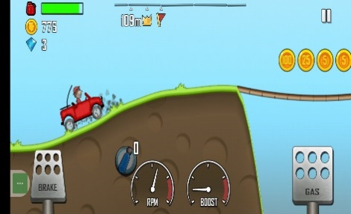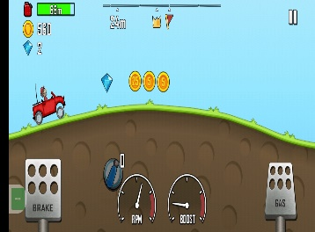

Car running Brakes applied Exit Game StartGame

**Fig. 1.1** : Voice Recognition & Hand Gesture Recognition System

**Step 1- Voice recognition for starting and ending the game :**

The game initiates with the voice command "start" and concludes upon detection of the command "end" by the PyAudio library, offering mouse-free control for seamless gameplay.

**Step 2 - Hand Gesture:**

In the interaction scenario, an individual executes distinct hand gestures within the proximity of a camera or sensor embedded in a device. These gestures encompass a spectrum of movements, positions, or signs articulated through hand motions. Each gesture carries its unique significance, contributing to the nuanced language communicated to the system.

**Step 3 - Image Captured by Device:**

Upon execution, the device's camera swiftly captures either a single image or a sequence of images encapsulating the intricacies of the performed hand gesture. Subsequently, the device's software meticulously processes these images, dissecting the visual data to discern the essence and intent behind the gesture's manifestation.

**Step 4 - Action to be Performed Based on Hand Gestures:**

In this stage of the process, the software embedded within the device undertakes a meticulous analysis of the captured images, aiming to discern and interpret the

intricate nuances of the hand gesture presented. Drawing from its programmed algorithms, the software identifies the specific gesture enacted by the user. Depending on the recognized gesture, the device is then primed to execute a predefined action, such as propelling the car forward or applying the brakes with precision and responsiveness.

**4. Working**

The system begins by importing essential libraries for seamless operation. Cvzone, an extension of OpenCV, facilitates webcam frame capture and processing. Hand Detector, a module from Cvzone, assists in identifying and tracking hands in real-time. Moreover, the Hand Tracking Module, a bespoke component, enhances the system's hand tracking functionalities.

Integration with PyAudio, coupled with a speech recognition library like SpeechRecognition, enables voice command recognition. This functionality triggers actions such as starting or exiting the game upon detection of specific voice commands. The functionalities of Key and Controller from the pynput module replicate keyboard key presses and releases, enabling seamless and user- friendly interaction.

Upon initialization, the webcam capture is configured to utilize the default webcam (0) and adjust the captured video frame dimensions to 720 pixels in width and 420 pixels in height. A while loop governs the continuous capture and processing of frames from the webcam. In this loop, the Hand Detector object discerns hands present in the captured frame, providing a list of detected hands while annotating the image with hand tracking details.

Based on the positions of the fingers detected, the system simulates keyboard key presses and releases, enabling seamless interaction and control within the game environment. This dynamic integration of gesture and voice recognition technologies enhances the user experience, offering intuitive control mechanisms for gameplay.

|  |  |
| --- | --- |
| Gesture Detected | Action |
| All fingers closed [0 0 0 0 0] | Depress the left arrow key and release the right arrow key subsequently. |
| All fingers open  [1 1 1 1 1] | Activate the right arrow keyand release the left arrow key afterward. |
| No specific gesture detected | Let go of both the left and right arrow keys to prevent ongoing input. |

**Table 2.** Control Mechanisms

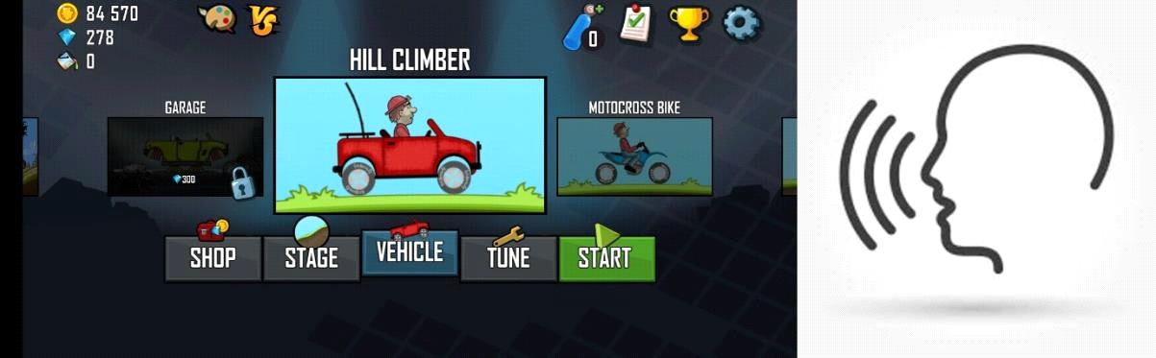

**Fig.2.1** Starting the game with voice command

Fig 2.1 Initiate the hill climbing game with a voice prompt of "Start"., Enable your camera to capture live video feed.

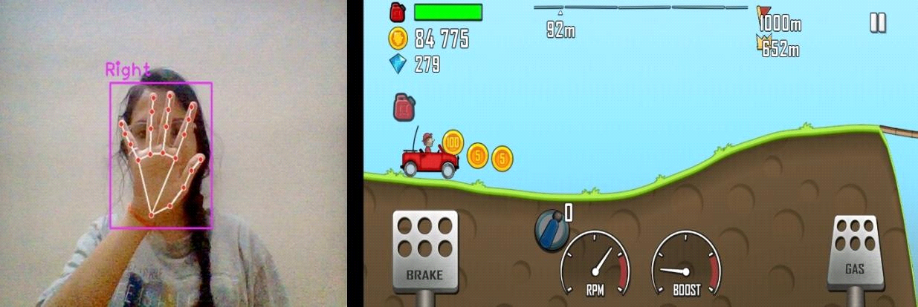

**Fig.2.**2 Gesture recognized to move the car forward

In fig 2.2 , Commence the game by extending your hand with open palms, activating the car to move forward as all fingers are extended, pressing the gas (right) key.

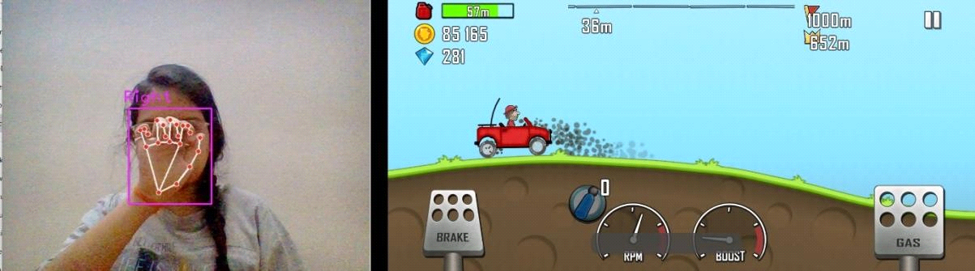

**Fig.2.3** Gesture recognized to stop the car

In fig 2.3 , Cease the movement of the car in the hill climbing game by closing your hand, causing all fingers to close and consequently pressing the left key, which applies the brake and halts the car.

****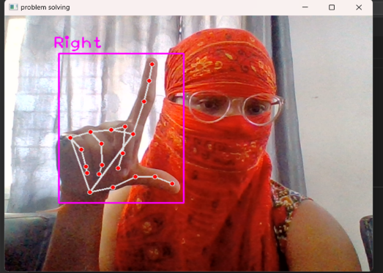 **Fig 2.4** To pause the game

In the above figure 2.4, game is been paused using the hand gesture.



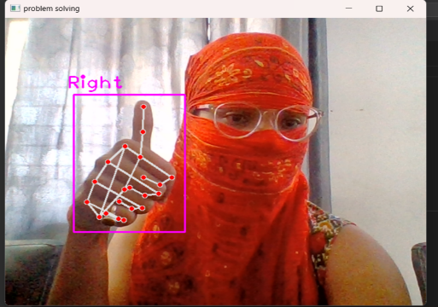 **Fig 2.5** To exit the game

In the above fig 2.5, game can be exited using the hand gesture.

**5 Conclusion**

The project outlined above heralds a groundbreaking approach to human-computer interaction, showcasing the strength of hand gestures as a novel input method for controlling games and other applications. By harnessing the power of hand gestures, users can seamlessly navigate digital environments without the need for traditional input devices, ushering in a new era of hands-free computer control. This innovative system not only underscores the remarkable capabilities of gesture-based interfaces but also underscores their transformative impact on accessibility and user experiences across diverse domains. From gaming to industrial applications, the integration of hand gestures as a primary input method holds the promise of revolutionizing how we interact with technology. The future envisioned, where non-verbal communication via hand gestures becomes ubiquitous, signifies a transformative shift in human-computer interaction. Beyond spoken and written language, hand gestures present a universal means of intuitive communication, amplifying user engagement. The system's emphasis on detecting shape-based features through a lone camera heralds a pivotal step toward this vision. Harnessing computer vision, the system adeptly deciphers hand movements, facilitating seamless real-time interaction with digital interfaces.

Moreover, the project underscores the broader implications of gesture- based interfaces in enhancing accessibility and inclusivity. As technology continues to evolve, gesture-based systems have the potential to break down barriers and empower individuals with diverse abilities to fully participate in the digital world. In fields such as farming, industries, and beyond, the integration of gesture-based interfaces promises to streamline workflows, improve efficiency, and enhance overall user experiences. By embracing the potential of hand gestures as a powerful input method, we embark on a journey towards a more connected, accessible, and immersive digital future.

**Conflicts of Interest:** All theauthor(s) declare(s) that there is no conflict of interest

**Data availability:** Availability of data as per the demands of the user in which python libraries are available online

**6 References**

1. Ismail, A.P., Azahaar, Muhammad, Tahir, Noorita, Daud, Kamarulazhar, and Kasim, Nazirah. "Human Action Recognition (HAR) using Image Processing on Deep Learning." Published in 2023, this paper delves into the intricacies of human action recognition, leveraging image processing techniques within the realm of deep learning.
2. Kotavenukaa, S., Kodakandla, H., Krishna, N.S., and Rao, S.P.V. present their work on "Hand Gesture Recognition" in 2023, focusing on the identification and interpretation of hand gestures.
3. Chang, V., Eniyola, RO., Golightly, L., and Xu, QA. explore the domain of human-computer interaction in their paper titled "An Exploration into Human-Computer Interaction: Hand Gesture Recognition Management in a Challenging Environment," published in SN Comput Sci in 2023.
4. Mujahiid, A. et al., introduce "Real-Time Hand Gesture Recognition Based on Deep Learning YOLOv3 Model" in Applied Sciences-Basel in 2021.
5. Turr, A.O. and Keyles, A.Y. evaluate hidden Markov models in "Evaluation of Hidden Markov Models Using Deep CNN Features in Isolated Sign Recognition," published in Multimedia Tools and Applications in 2021.
6. Real-Time Hand Gesture Recognition Using Finger Segmentation Zhi-hua Chen,1Jung-Tae Kim,1Jianning Liang,1Jing Zhang,1,2and Yu-Bo Yuan1
7. Hand Gesture Recognition Based on Computer Vision: A Review of Techniques [M. Oudah](https://www.semanticscholar.org/author/M.-Oudah/1908807827), [A. Al-Naji](https://www.semanticscholar.org/author/A.-Al-Naji/123156822), [J. Chahl](https://www.semanticscholar.org/author/J.-Chahl/144608860)
8. “Enhanced Hand Gesture Recognition System,” Gagandeep Singh Narula , Aniket Singh Rawat.